Student ID: 11510224 Name:谢济宇
Living in the quantum world
Background: It is commonly recognized that the quantum mechanics is a theory of molecules, atoms, subatomic particles.Most physicists believe that this theory applies to everything , no matter what the size, including living organisms.In the quantum world,nothing is certain,it’s a world of probabilities.
As Michio Kaku said (Michio Kaku, a famous physicist and a co-founder of string field theory),’’The quantum theory offers a very different explanation of our world,it is so strange and bizarre even Einstein couldn’t get his head around it’’ It forces us to accept a new and unfamiliar picture of our world and rethink how we look at the universe.
Schrödinger's Cat and The Quantum Pigeonhole Principle:
Schrödinger’s cat is one of the most famous thought experiments in physics,.In 1935, Erwin Schrödinger ,the 1933 Nobel Prize -winning Austrian physicist,came up with this thought experiments to illustrate how the microworld and macroworld couple to each other. This experiment says that a radioactive atom can be both decayed and not decayed at the same time. If the atom is linked to a bottle of cat poison, so that the cat dies if the atom decays, then the animal gets left in the same quantum limbo as the atom.In other worlds,the cat is alive as well as died before the box is opened.The weirdness of the one infects the other. Size does not matter. The puzzle was why cat owners only ever see their pets as alive or dead.
In 2016, Researchers from Chapman University’s Institute introduced a new quantum phenomenon(Yakir Aharonov, E3053, doi: 10.1073/pnas.1602477113)which the authors called the “quantum pigeonhole principle.”—“If you put three particles in two boxes, necessarily two particles will end up in the same box.We find instances when three quantum particles are put in two boxes, yet no two particles are in the same box.”
In the modern point of view, the world looks classical because the complex interactions that an object has with its surroundings conspire to conceal quantum effects from our view. Information tend to dissipate due to these interactions,the leakage of information is the essence of a process known as decoherence.And because of that,quantum has some unique properties such as superposition and entanglement.
Quantum Property 1: Superposition
Superposition is the state where atoms and subatomic particles can exist in multiple states and even multiple locations simultaneously.Particles can be in two “spin states” at once—both spin up and spin down,for example.Whereas a classical object, such as a wheel, can spin in only one direction at a time.
Quantum Property 2: Entanglement
Albert Einstein called the quantum entanglement “spooky action at a distance”.Entanglement is an instantaneous connection in two particles where an action performed on one of them affects the other even when they are separated in space.
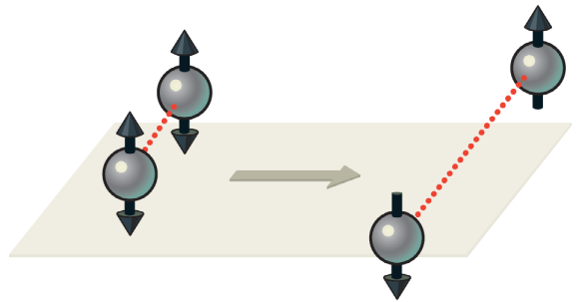
As figure 2 shown(Vlatko Vedral,June 2011,Scientific American),the entangled particles is initially in a superposition of both up and down spin states.Depending on the type of entanglement, if the first particle is in the spin-up state, the second will always be in the spin-down state,This means the particles will always pick coordinated states when an outside measurement forces the two to “pick” a single state.When multiple qubits are entangled, an operation performed on one will affect all the others instantaneously,allowing for unprecedented parallel processing.


Fig1.Superposition . Fig2.Entanglement.
One application：One application using these unique quantum properties shown above is quantum computing. Quantum machines could make previously unthinkable computing, communication and measurement tasks trivial.But it still need a great effort to complete the quantum theory and achieve the goal.

